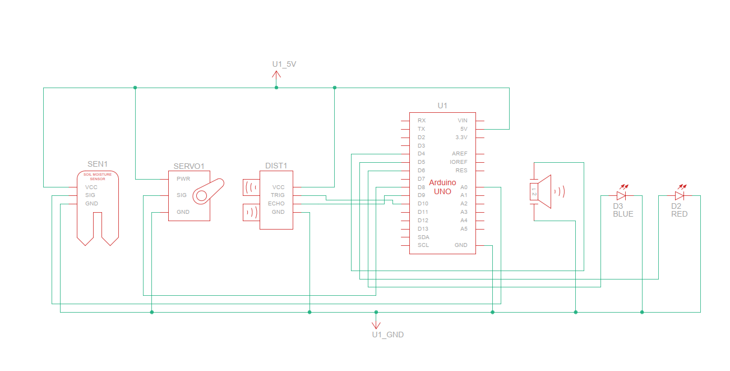

DRY & WET GARBAGE SEPERATORS [SCHEMATIC CIRCUIT DESIGN]